**Module 1 – Overview of IT Industry**

**What is a Program?**

**LAB EXERCISE:**

**Write a simple "Hello World" program in two different programming languages of your choice. Compare the structure and syntax.**

In C Language :

#include<stdio.h>

int main()

{

printf(“hello world”);

return 0;

}

where ,

# -prepocessor

include-keyword

stdio.h-input output header file

int main( )-predefine function

In Python :

print(“hello world”)

**THEORY EXERCISE:**

**Explain in your own words what a program is and how it functions.**

Program :A program is a set of algorithms.

It converts high level language into low level language that a machine can understand.

What is Programming?

Programming is the process of creating instructions that a computer can understand and execute.

**THEORY EXERCISE:**

**What are the key steps involved in the programming process?**

The programming process consist of several key steps to ensure the development of a functional and reliable program.

This steps are :

1. Problem analysis
2. Planning and design
3. coding
4. testing and debggging
5. Optimization
6. Documentation
7. deploument
8. Maintenance

**Types of Programming Languages**

**THEORY EXERCISE:**

**What are the main differences between high-level and low-level programming languages?**

* **Abstraction:** High-level languages are abstracted from hardware, while low-level languages are closer to machine code and offer more direct control over hardware.
* **Ease of Use:** High-level languages are easier to read, write, and maintain, while low-level languages are harder and require more detailed knowledge of the system.
* **Control:** Low-level languages provide more control over memory and hardware, while high-level languages abstract these details.
* **Performance:** Low-level languages are typically faster and more efficient, but high-level languages are more portable and easier to develop with.
* **Error Handling:** High-level languages include built-in safety features like automatic memory management, while low-level languages require manual management, increasing the chance of errors.

In essence**,** high level language are user-friendly and portable, whereas low-level language offer better performance and hardware control.

**World Wide Web & How Internet Works**

The world wide web is a service that operates over the Internet. It refers to the system of interconnected documents and resources that are accessed via web browsers like Google Chrome, Firefox, etc.The Web uses the HTTP (Hyper Text Transfer Protocol) to transfer data.

**LAB EXERCISE:**

**Research and create a diagram of how data is transmitted from a client to a server over the internet.**



**THEORY EXERCISE:**

**Describe the roles of the client and server in web communication.**

**Role of Client :**

* Makes requests for resources (e.g., web pages, images).
* Renders the received data for display to the user.
* Sends input data (e.g., form submissions).
* May manage sessions and cookies.

**Role of** **Server:**

* Hosts and serves resources to the client.
* Processes requests and generates responses.
* Handles authentication, session management, and security.
* Sends back HTTP responses with requested content.

**Network Layers on Client and Server**

**LAB EXERCISE:**

**Design a simple HTTP client-server communication in any language.**

### Step 1: Create the HTTP Server

# server.py

import http.server

import socketserver

PORT = 8000

class SimpleRequestHandler(http.server.SimpleHTTPRequestHandler):

def do_GET(self):

# Send an HTTP response with a simple message

self.send_response(200)

self.send_header('Content-type', 'text/html')

self.end_headers()

self.wfile.write(b'Hello, this is the server response!')

# Set up the server

Handler = SimpleRequestHandler

httpd = socketserver.TCPServer(("", PORT), Handler)

print(f"Serving on port {PORT}...")

httpd.serve_forever()

Step 2: Create the HTTP Client

# client.py

import requests

url = "http://localhost:8000" # URL of the server

response = requests.get(url)

if response.status_code == 200:

print("Server response:", response.text)

else:

print("Failed to get a valid response from the server.")

Step 3: Running the Example

**Start the server**: Open a terminal and run the server.py script:

python server.py

**Run the client**: In another terminal window, run the client.py script:

python client.py

Expected Output:

Server response: Hello, this is the server response!

**THEORY EXERCISE:**

**Explain the function of the TCP/IP model and its layers.**

The **TCP/IP model** (Transmission Control Protocol/Internet Protocol model) is a conceptual framework used to describe how data is transmitted over networks, particularly the internet

It consists of a set of protocols that govern the communication between devices on a network.

The TCP/IP model is composed of **four layers**, each responsible for different aspects of the communication process, and it helps ensure reliable and efficient transmission of data across networks.

The four layers of the **TCP/IP model** are:

1. **Application Layer**
2. **Transport Layer**
3. **Internet Layer**
4. **Link Layer** (sometimes called the Network Access Layer)

#### ****Application Layer****

* **Function**: The topmost layer, where communication begins. It provides network services to end-user applications, enabling programs to communicate over a network.

#### 2. ****Transport Layer****

* **Function**: The Transport Layer ensures that data is delivered error-free, in sequence, and without losses. It also handles the segmentation and reassembly of data, flow control, and error correction.

#### 3. ****Internet Layer****

* **Function**: The Internet Layer is responsible for routing packets of data from the source device to the destination device, even across multiple networks (e.g., from one sub-net to another or across the internet). It defines logical addressing and provides mechanisms for routing data between devices over an internetwork (network of networks).

#### 4. ****Link Layer**** (Network Access Layer)

* **Function**: The Link Layer is responsible for the actual transmission of data over the physical network. It deals with hardware addressing (MAC addresses) and the physical transmission medium (e.g., Ethernet cables, Wi-Fi signals).

**Client and Servers**

**THEORY EXERCISE:**

**Explain Client Server Communication**

Client-server communication refers to a network architecture in which one device (the **client**) requests services or resources from another device (the **server**), which provides those services.

The **client** typically initiates the communication, and the **server** responds to requests, providing data, services, or resources.

This communication model is the foundation of most modern networks, including the Internet, where applications like web browsers (clients) interact with web servers.

### ****Key Concepts of Client-Server Communication:****

**1. Client**:

* A **client** is an application or device that makes requests for data, services, or resources. It is usually a user-facing application that interacts with the server to request specific tasks.
* **Example**: A web browser is a client that requests web pages from a web server.

**2.Server**:

* A **server** is a device or application that listens for incoming requests from clients. The server processes the request and sends a response back to the client.
* **Example**: A web server that responds to HTTP requests by serving web pages.

**3.**  **Request-Response Cycle**:

* **Request**: The client sends a request to the server, asking for a specific resource or service.
* **Response**: The server processes the request and sends a response back to the client.

**Types of Internet Connections**

**LAB EXERCISE:**

**Research different types of internet connections (e.g., broadband, fiber, satellite)and list their pros and cons.**

Here is an overview of **different types of internet connections**, their **pros and cons**:

### 1. ****Broadband (DSL and Cable)****

Broadband is a high-speed internet connection that provides fast and reliable access to the internet. It is typically used to refer to both **DSL** (Digital Subscriber Line) and **cable** internet services, both of which are commonly used for home and business internet connections.

#### ****DSL (Digital Subscriber Line)****

* **How It Works**: DSL uses existing telephone lines to deliver internet services. It splits the signal into two parts: one for voice calls and one for data.

##### ****Pros****:

* **Availability**: Available almost anywhere where telephone lines exist.
* **Cost**: Generally cheaper than fiber optic or cable connections.
* **Dedicated Line**: Offers a dedicated line, meaning the bandwidth is not shared with neighbors, leading to more stable speeds (although it can degrade with distance from the provider).

##### ****Cons****:

* **Speed**: Slower than cable and fiber connections. Speed drops the further the user is from the provider’s central office.
* **Reliability**: May be affected by interference or poor-quality phone lines.
* **Upload Speeds**: Typically, DSL provides slower upload speeds compared to download speeds.

#### ****Cable Internet****

* **How It Works**: Cable internet uses the same coaxial cables that transmit cable TV signals, but for internet data.

##### ****Pros****:

* **Faster Speeds**: Faster than DSL, with typical speeds ranging from 25 Mbps to 1 Gbps, depending on the service provider.
* **Availability**: Widely available in urban and suburban areas.
* **No Need for New Infrastructure**: Since cable internet uses existing cable lines, it doesn't require additional infrastructure.

##### ****Cons****:

* **Shared Bandwidth**: The connection is shared with neighbors, so during peak hours, speeds can slow down.
* **Availability**: Availability can be limited in rural areas.
* **Price**: Typically more expensive than DSL, though still cheaper than fiber.

### 2. ****Fiber Optic Internet (FTTH/Fiber to the Home)****

Fiber-optic internet transmits data using light over thin strands of glass or plastic. It’s the fastest and most reliable type of internet connection.

#### ****Pros****:

* **Speed**: Extremely fast, offering speeds up to 10 Gbps (or more in some cases). This is ideal for streaming high-definition video, online gaming, and large file transfers.
* **Symmetrical Speeds**: Offers the same upload and download speeds, which is ideal for businesses and activities that require high upload speeds (e.g., cloud backup, video conferencing).
* **Reliability**: Less prone to interference and weather-related disruptions.

#### ****Cons****:

* **Availability**: Limited availability, especially in rural or remote areas. Fiber infrastructure is expensive to deploy.
* **Cost**: Typically more expensive than DSL or cable internet.
* **Installation**: Installation can be complex and time-consuming, requiring new infrastructure in many cases.

### 3. ****Satellite Internet****

Satellite internet provides broadband via satellites in geostationary orbit, typically used in rural or remote areas where other broadband connections are unavailable.

#### ****Pros****:

* **Wide Availability**: Can be used almost anywhere, especially in rural and remote areas where terrestrial broadband connections aren't available.
* **Mobility**: Portable options are available, meaning users can access the internet in different locations (e.g., RVs, boats, or remote work locations).

#### ****Cons****:

* **High Latency**: Due to the long distance data must travel to the satellite (geostationary satellites are 35,000 km above the Earth), satellite internet has high latency (often 600 ms or more).
* **Slower Speeds**: Speed is often much slower than fiber or cable (typically ranging from 25 Mbps to 100 Mbps, with some newer systems achieving faster speeds).
* **Weather Dependent**: Performance can be significantly impacted by weather conditions, like heavy rain, thunderstorms, or snow.
* **High Cost**: Generally more expensive than other types of broadband, both for equipment (dish, modem) and service.

### 4. ****Fixed Wireless Internet****

Fixed wireless internet is a broadband internet service that uses radio signals to transmit internet data to a fixed antenna located on the subscriber's property.

#### ****Pros****:

* **Availability**: Can be available in rural areas where fiber or cable isn't feasible.
* **Installation**: Quick to install compared to fiber, especially in areas where the infrastructure is already in place.
* **Less Interference**: Less prone to interference from weather compared to satellite connections.

#### ****Cons****:

* **Line of Sight**: Requires a direct line of sight between the antenna and the base station. This can limit availability depending on terrain (e.g., mountains or tall buildings).
* **Speed**: Not as fast as fiber or cable internet, with speeds typically ranging from 10 Mbps to 100 Mbps.
* **Interference**: Signal quality can be affected by local interference (e.g., buildings, trees).

### 5. ****5G and Mobile Broadband****

5G is the latest generation of mobile networks and offers internet access via mobile data. It is often used in areas where fixed-line broadband is unavailable or as a backup.

#### ****Pros****:

* **Speed**: 5G networks can provide extremely fast speeds, often exceeding 1 Gbps, which is comparable to fiber in some cases.
* **Low Latency**: 5G has significantly lower latency than previous mobile networks, which is important for activities like gaming and video conferencing.
* **Mobility**: Offers internet access anywhere there is 5G coverage, ideal for mobile devices or for users who travel frequently.

#### ****Cons****:

* **Availability**: 5G networks are still being rolled out and are not universally available, especially in rural or remote areas.
* **Cost**: Mobile data plans for 5G can be expensive, and 5G hardware (modems, routers, etc.) may have a higher upfront cost.
* **Network Congestion**: In densely populated areas, 5G speeds can drop due to high demand, as the network may become congested.

### 6. ****Dial-Up Internet****

Dial-up internet is the oldest form of internet access. It uses a standard telephone line to connect to the internet by dialing a number.

#### ****Pros****:

* **Availability**: Available almost anywhere with a landline phone connection.
* **Cost**: Usually very inexpensive, with minimal or no monthly fees.

#### ****Cons****:

* **Speed**: Extremely slow (typically around 56 Kbps), making it unsuitable for modern internet use such as streaming, gaming, or even browsing most websites.
* **Connection Quality**: Can be affected by phone line quality and is subject to frequent disconnects.
* **Simultaneous Use**: Cannot be used for phone calls while connected to the internet, as it ties up the phone line.

**THEORY EXERCISE:**

**How does broadband differ from fiber-optic internet?**

### ****Broadband****:

* **Definition**: Broadband is a general term used to describe any high-speed internet connection that provides fast and always-on access to the internet. It refers to the capacity of the internet connection to transmit data at high speeds.

### ****Fiber-Optic Internet****:

* **Definition**: Fiber-optic internet is a specific type of broadband internet that uses **fiber-optic cables** to transmit data. These cables consist of glass or plastic fibers that carry data as light signals, allowing for incredibly fast and efficient transmission of information.

### Key Differences:

* **Technology**: Broadband encompasses various internet technologies, while fiber-optic internet is a specific type of broadband using light signals to transmit data.
* **Speed**: Fiber-optic internet is typically much faster than other broadband options (e.g., DSL, satellite, or cable).
* **Reliability**: Fiber-optic tends to be more reliable, with fewer issues related to signal loss or interference compared to other broadband types.

**Protocols**

**LAB EXERCISE:**

**Simulate HTTP and FTP requests using command line tools (e.g., curl).**

Here are concise examples of simulating HTTP and FTP requests using the curl command:

### ****HTTP Requests with**** curl

#### 1. ****GET Request****:

curl http://example.com

#### 2. ****GET Request with Headers****:

curl -H "User-Agent: CustomAgent" <http://example.com>

**3.POST Request with Form Data**:

curl -X POST -d "username=test&password=secret" <http://example.com/login>

#### 4. ****POST Request with JSON****:

curl -X POST -H "Content-Type: application/json" -d '{"username":"test","password":"secret"}' http://example.com/login

#### 5. ****PUT Request****:

curl -X PUT -H "Content-Type: application/json" -d '{"name":"newName"}' http://example.com/api/resource/123

#### 6. ****DELETE Request****:

curl -X DELETE http://example.com/api/resource/123

#### 7. ****View Response Headers****:

curl -I http://example.com

### ****FTP Requests with**** curl

#### 1. ****FTP Download****:

curl -u username:password ftp://ftp.example.com/path/to/file.txt -o localfile.txt

#### 2. ****FTP Upload****:

curl -u username:password -T localfile.txt ftp://ftp.example.com/path/to/upload/

#### 3. ****List FTP Files****:

curl -u username:password ftp://ftp.example.com/path/to/directory/

These are the basic commands for HTTP and FTP requests with **curl**

**THEORY EXERCISE:**

**What are the differences between HTTP and HTTPS protocols?**



**Application Security**

**LAB EXERCISE:**

**Identify and explain three common application security vulnerabilities. Suggest possible solutions.**

### 1. ****SQL Injection (SQLi)****

#### ****Description:****

SQL Injection occurs when an attacker manipulates an application’s input fields (such as search bars or login forms) to execute arbitrary SQL queries. These queries can manipulate the database to retrieve sensitive information, modify data, or even delete it.

#### ****Impact:****

* Unauthorized access to sensitive data (e.g., usernames, passwords, financial records).
* Data corruption or loss.
* Complete compromise of the application’s database.

#### ****Solution:****

**Use Prepared Statements (Parameterized Queries):** Ensure that user input is not directly included in SQL queries. Prepared statements ensure that input is treated as data, not executable code.

### 2. ****Cross-Site Scripting (XSS)****

#### ****Description:****

XSS vulnerabilities occur when an attacker injects malicious scripts (usually JavaScript) into web pages viewed by other users. These scripts can execute actions in the context of a user’s browser, such as stealing session cookies, defacing the site, or redirecting users to malicious sites.

#### ****Impact:****

* **Session Hijacking:** Attackers can steal authentication cookies or session tokens to impersonate a user.
* **Phishing Attacks:** Malicious scripts can trick users into submitting sensitive information.
* **Defacement:** Attackers can modify the content of a web page to mislead or confuse users.

#### ****Solution:****

**Escape User Input:** Ensure that any user input rendered on web pages is properly escaped, so any HTML or JavaScript code is treated as data, not executable code

### 3. ****Cross-Site Request Forgery (CSRF)****

#### ****Description:****

CSRF occurs when a user is tricked into performing an unwanted action on a web application where they are authenticated. The attacker exploits the user's credentials by making an authenticated request (e.g., transferring money or changing account details) without the user’s consent.

#### ****Impact:****

* Unauthorized actions taken on behalf of the authenticated user (e.g., making a financial transaction, changing account settings).
* Data loss or modification due to unauthorized actions.

#### ****Solution:****

**Anti-CSRF Tokens:** Generate a unique, unpredictable token for each user session. Include this token in forms and validate it on the server before processing any state-changing requests (like submitting a form).

**THEORY EXERCISE:**

**What is the role of encryption in securing applications?**

Encryption plays a crucial role in securing applications by protecting sensitive data from unauthorized access. It converts readable information into an unreadable format using algorithms and keys, ensuring that only authorized users or systems can decrypt and access the original data. This helps safeguard data both at rest (stored data) and in transit (data being transmitted), preventing breaches, data theft, and ensuring confidentiality, integrity, and privacy.

**Software Applications and Its Types**

**LAB EXERCISE:**

**Identify and classify 5 applications you use daily as either system software or application software.**

1. **Operating System (e.g., Windows, macOS)** – **System Software**: Manages hardware and software resources.
2. **Web Browser (e.g., Chrome, Firefox)** – **Application Software**: Used for browsing the internet.
3. **Antivirus Software (e.g., Norton, McAfee)** – **System Software**: Protects the system from malware and viruses.
4. **Microsoft Word** – **Application Software**: Used for word processing and document creation.
5. **File Explorer (e.g., Windows Explorer)** – **System Software**: Manages file and folder operations on the device.

**THEORY EXERCISE:**

**What is the difference between system software and application software?**



**Software Architecture**

**LAB EXERCISE:**

**Design a basic three-tier software architecture diagram for a web application.**

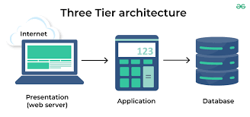

**THEORY EXERCISE:**

**What is the significance of modularity in software architecture?**

**Modularity** in software architecture is significant because it promotes a design where a system is divided into smaller, manageable, and independent components or modules, each responsible for a specific functionality.

Here are the key benefits of modularity:

* Improved Maintainability
* Scalability
* Reusability
* Separation of Concerns
* Parallel Development
* Flexibility
* Testing and Debugging

**Layers in Software Architecture**

**LAB EXERCISE:**

**Create a case study on the functionality of the presentation, business logic, and data access layers of a given software system.**

### ****Case Study: E-Commerce Web Application****

#### Overview

An e-commerce web application allows customers to browse products, add them to their cart, place orders, and make payments. The system is built using a **three-tier software architecture** comprising the **Presentation Layer**, **Business Logic Layer**, and **Data Access Layer**. Below, we examine the functionality of each layer in this context.

### ****1. Presentation Layer (UI)****

#### ****Functionality****:

The Presentation Layer is responsible for everything the user interacts with. This layer serves as the front-end of the application, providing a user interface (UI) for browsing products, managing shopping carts, checking out, and viewing order details.

**Technologies**:

* HTML, CSS, JavaScript (for dynamic interactions)
* Front-end frameworks: React, Angular, or Vue.js
* HTTP/RESTful APIs for communication with the back-end

### ****2. Business Logic Layer (API)****

#### ****Functionality****:

* The Business Logic Layer processes requests from the Presentation Layer and implements the core functionality of the e-commerce system. It acts as the mediator between the user interface and the data access layer, performing operations such as

**Technologies**:

* Programming languages: Python (Django, Flask), JavaScript (Node.js), Ruby (Rails), Java (Spring)
* REST APIs to communicate with the UI and data layers
* Payment gateway APIs (e.g., Stripe, PayPal) for payment processing
* Authentication and authorization mechanisms (JWT, OAuth)

### ****3. Data Access Layer (Database)****

#### ****Functionality****:

The Data Access Layer is responsible for interacting with the database to retrieve and store data. It handles operations like querying product details, saving order information, and updating stock quantities. It acts as a bridge between the business logic layer and the database.

**Technologies**:

* Relational Databases: MySQL, PostgreSQL, SQL Server
* NoSQL Databases (for unstructured data): MongoDB, Cassandra
* Object-Relational Mapping (ORM) tools: SQLAlchemy (Python), Hibernate (Java), Sequelize (Node.js)

**THEORY EXERCISE:**

**Why are layers important in software architecture?**

Layers are important in software architecture because they promote **separation of concerns**, making the system more **modular** and easier to maintain. By dividing the system into distinct layers, each responsible for a specific function, it allows for:

1. **Independence**: Each layer can evolve or be replaced without impacting others, promoting flexibility and scalability.
2. **Maintainability**: Changes or fixes in one layer are localized, reducing the risk of unintended side effects across the system.
3. **Reusability**: Layers can be reused across different applications or parts of the same application, reducing redundancy.
4. **Testability**: Layers can be tested independently, improving the reliability and quality of the system.
5. **Security**: Sensitive data or logic can be isolated within specific layers, enhancing security.

This structure ensures that the system remains organized, manageable, and adaptable as it grows.

**Software Environments**

**LAB EXERCISE:**

**Explore different types of software environments (development, testing, production).Set up a basic environment in a virtual machine.**

In software development, different **environments** are used to ensure smooth development, testing, and deployment. These environments provide isolated spaces where the application can be developed, tested, and finally deployed to end-users. Let's explore the three main types of software environments and how to set up a basic environment in a **virtual machine (VM)**.

### ****Types of Software Environments****

### ****Development Environment****:

1. Testing Environmrnt
2. Production Environment

Setting Up a Basic Software Environment in a Virtual Machine (VM):

1. Install VirtualBox

2. Download an OS Image

3. Create a New Virtual Machine

4. Install the Operating System

5. Install Required Development Tools

6. Set Up a Database (Optional)

**7. Set Up a Local Web Server (Optional)**

**THEORY EXERCISE:**

**Explain the importance of a development environment in software production.**

A **development environment** is crucial in software production because it provides a controlled, isolated space where developers can write, test, and debug code efficiently. It ensures **consistency**, **collaboration**, and **productivity** by offering the necessary tools (IDEs, version control, build systems) and configurations (databases, frameworks). This environment allows for fast iteration, **safe experimentation**, and early detection of issues, ultimately improving **code quality** and reducing bugs in later stages like testing and production. Without a proper development environment, software projects would be prone to errors, delays, and inefficiencies.

**Source Code**

**LAB EXERCISE:**

**Write and upload your first source code file to Github.**

**THEORY EXERCISE:**

**What is the difference between source code and machine code?**

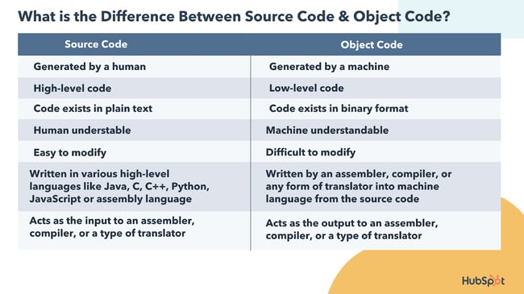

**Github and Introductions**

**LAB EXERCISE:**

**Create a Github repository and document how to commit and push code changes.**

**THEORY EXERCISE:**

**Why is version control important in software development?**

Version control is essential in software development because it tracks changes to the code base, enabling collaboration, code recovery, and rollback. It allows multiple developers to work on the same project without conflicts, ensures code integrity, and supports features like branching, merging, and continuous integration. Version control also provides an audit trail, improving accountability and code quality while making it easier to manage and deploy code in teams.

**Student Account in Github**

**LAB EXERCISE:**

**Create a student account on Github and collaborate on a small project with a classmate.**

**THEORY EXERCISE:**

**What are the benefits of using Github for students?**

Using **GitHub** offers several key benefits for students, especially those pursuing software development, programming, or computer science-related fields.

Here’s a quick overview of the advantages:

1.Version Control and Collaboration

2.Portfolio Building

3.Learning Git and GitHub Skills

4.Code Sharing and Backup

5.Learning and Practice with Open Source

6.Free Hosting for Personal Projects

7.Community and Networking

8.Issue Tracking and Project Management

9.Resume and Job Search Enhancement

10.Free for Students

**Types of Software**

**LAB EXERCISE:**

**Create a list of software you use regularly and classify them into the following categories: system, application, and utility software.**

1. **System Software**: Operating systems (Windows, macOS, Linux), device drivers.

2. **Application Software**: Word processors (Microsoft Word), web browsers (Google Chrome), communication tools (Slack), and creative tools (Photo shop).

3. **Utility Software**: Cleanup tools (CCleaner), antivirus software (Malwarebytes), cloud storage services (Dropbox).

**THEORY EXERCISE:**

**What are the differences between open-source and proprietary software?**

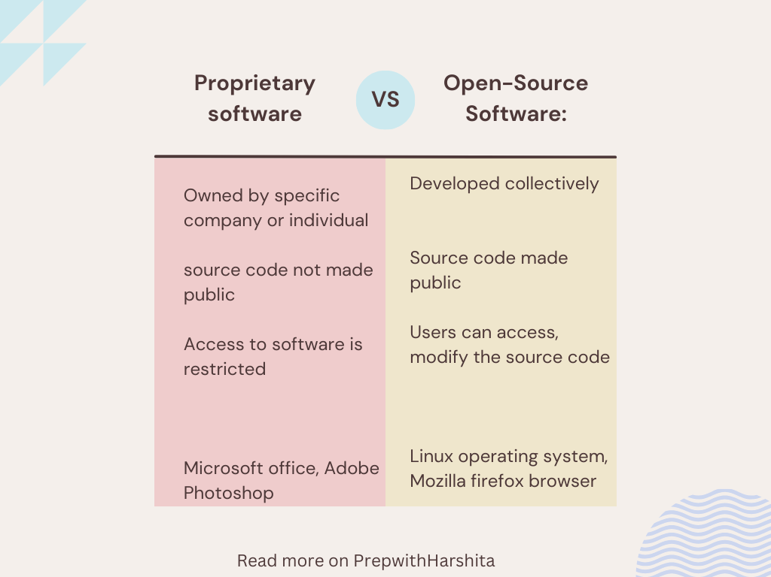

**GIT and GITHUB Training**

**LAB EXERCISE:**

**Follow a GIT tutorial to practice cloning, branching, and merging repositories.**

1. Clone a Repository

Step 1: Find a Repository to Clone

https://github.com/your-username/my-project.git

Step 2: Clone the Repository

git clone https://github.com/your-username/my-project.git

cd my-project

2. Create a New Branch

Step 1: List All Branches

git branch

Step 2: Create a New Branch

git checkout -b feature-xyz

Step 3: Verify the Branch

git branch

3. Merge the Feature Branch into the Main Branch

Step 1: Merge the Branch

git merge feature-xyz

Step 2: Resolve Merge Conflicts (If Any)

git add <file-with-conflict>

git commit -m "Resolve merge conflicts"

**THEORY EXERCISE:**

**How does GIT improve collaboration in a software development team?**

### ****How Git Improves Collaboration****

* **Branching** allows parallel development, isolating changes to different features or fixes.
* **Merging** integrates changes seamlessly, with conflict resolution tools to maintain code integrity.
* **Distributed Version Control** gives developers local copies of the repository, enabling offline work and better collaboration across locations.
* **Version History** and **Commit Logs** help teams track changes, maintain accountability, and recover previous versions.
* **Pull Requests and Code Reviews** improve code quality by facilitating peer review and ensuring changes are well-tested before integration.
* **Transparency and Communication** are enhanced through descriptive commit messages and visibility into each developer’s work.
* **Remote Repositories** and **Forking** make it easier for distributed teams to work together on the same project, even if they are located across different time zones.

**Application Software**

**LAB EXERCISE:**

**Write a report on the various types of application software and how they improve productivity.**

### **Types of Application Software and Their Impact on Productivity**:

### ****1. Productivity Software****

**Impact on Productivity**:

**Time savings**: Automated formatting, spell check, and templates streamline document creation and editing.

**Collaboration**: Real-time document sharing and editing across teams, improving workflow and reducing back-and-forth communication.

**Data management**: Spreadsheets enable fast data analysis, calculations, and visualization, facilitating decision-making.

### ****2. Communication Software****

**Impact on Productivity**:

**Instant communication**: Instant messaging and email allow quick clarification of issues and faster decision-making.

**Remote collaboration**: Video conferencing tools like Zoom enable virtual meetings, supporting remote work and reducing travel time.

**Team coordination**: Group chats and shared channels in tools like Slack ensure smooth communication and project tracking.

### ****3. Project Management Software****

**Impact on Productivity**:

**Task management**: These tools help break down complex projects into manageable tasks with deadlines and priorities.

**Resource allocation**: Project management software ensures that resources are used efficiently and deadlines are met.

**Tracking progress**: Gantt charts and Kanban boards allow teams to visualize project timelines and status in real-time.

### ****4. Accounting and Financial Software****

**Impact on Productivity**:

**Automated bookkeeping**: These tools automate invoicing, payroll, and financial reporting, saving time on manual calculations.

**Real-time financial tracking**: Provides up-to-date insights into cash flow, allowing for informed financial decisions.

**Tax compliance**: Simplifies tax filing and ensures accurate, timely submissions, reducing the risk of errors and penalties.

### ****5. Design and Creative Software****

**Impact on Productivity**:

**Creative efficiency**: Tools like Photoshop and Illustrator speed up the design process with features like templates, presets, and automated actions.

**Collaboration**: Cloud-based platforms allow multiple users to collaborate on design projects in real-time.

**Quick turnaround**: Intuitive interfaces and built-in design assets enable faster content creation and editing

### ****6. Database Management Software****

**Impact on Productivity**:

**Data organization**: DBMS software ensures data is structured and easily retrievable, enabling quicker access to critical information.

**Security and integrity**: Ensures that business data is accurate, consistent, and secure, reducing errors and data loss.

**Automation**: Automates tasks such as data backups and queries, saving time and reducing manual labor.

**THEORY EXERCISE:**

**What is the role of application software in businesses?**

Application software plays a vital role in enhancing business operations by automating tasks, improving communication, increasing efficiency, and enabling better decision-making. These software solutions are designed to address specific business needs, ranging from word processing and data management to accounting and customer relationship management (CRM). Here’s a breakdown of the key roles that application software plays in businesses:

**Software Development Process**

**LAB EXERCISE:**

**Create a flowchart representing the Software Development Life Cycle (SDLC).**

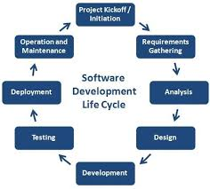

**THEORY EXERCISE:**

**What are the main stages of the software development process?**

The software development process typically follows a structured approach to create high-quality software systems.

The **main stages** of the software development process are as follows:

1.Requirement Gathering and Analysis

2.System Design

3.Implementation

4.Testing

5.Deployment

6.Maintenance and Support

**Software Requirement**

**LAB EXERCISE:**

**Write a requirementspecification for a simple library management system.**

1.Introduction

This document specifies the functional and non-functional requirements for a **Library Management System (LMS)** that enables librarians to manage books, users, and library transactions (borrowing and returning books).

1. Scope

3.Functional Requirements

3.1 User Management

3.2 Book Management

3.3 Borrowing and Returning Books

3.4 Reporting

1. Non-Functional Requirement

4.1 Performance

4.2 Security

4.3 Usability

4.4 Availability

1. Constraints

6. Future Enhancements

**THEORY EXERCISE:**

**Why is the requirement analysis phase critical in software development?**

The **requirement analysis phase** is critical in software development because it:

1. **Defines the Scope**: It helps clarify what the system should do, preventing scope creep and ensuring all stakeholders have aligned expectations.
2. **Prevents Misunderstanding**: It helps identify and address any gaps or misunderstandings early on, reducing costly changes later.
3. **Guides Design and Development**: Clear requirements serve as the foundation for system design, architecture, and implementation, ensuring the final product meets user needs.
4. **Identifies Risks**: Potential challenges, such as technical constraints or resource limitations, are identified early, allowing for better planning.
5. **Improves Communication**: It fosters clear communication between stakeholders (users, developers, managers) and ensures everyone is on the same page.

**Software Analysis**

**LAB EXERCISE:**

**Perform a functional analysis for an online shopping system.**

### ****Functional Analysis for an Online Shopping System****

A **functional analysis** identifies and defines the key features and functionalities of an online shopping system, focusing on both customer and administrator interactions.

### ****1. User Registration and Authentication****

* **Register Account**: New users provide personal details to create an account.
* **Login/Logout**: Registered users log in and out securely.
* **Password Recovery**: Users can reset forgotten passwords.

### ****2. Product Management****

* **Browse Products**: Users browse product categories (e.g., electronics, clothing).
* **Search**: Users search by keywords, categories, or filters (price, ratings).
* **Product Details**: Display product info (price, description, reviews).

### ****3. Shopping Cart****

* **Add to Cart**: Users add items to the cart, selecting quantities.
* **View/Edit Cart**: View cart details, modify quantities, or remove items.
* **Save for Later**: Users can save items for future purchase.

### ****4. Checkout Process****

* **Billing and Shipping Info**: Users enter shipping and payment details.
* **Order Review**: A final summary of products, prices, and delivery costs.
* **Payment**: Users pay through integrated gateways (credit card, PayPal).
* **Order Confirmation**: After successful payment, users receive a confirmation with an order ID.

### ****5. Order Management****

* **Track Orders**: Users can track order status (processing, shipped, delivered).
* **View Order History**: Users can view past orders and statuses.
* **Cancel/Return**: Users request cancellations or returns based on store policies.

### ****6. Customer Support****

* **Live Chat**: Real-time support for inquiries or issues.
* **Help Center**: FAQ section, guides, and policies for self-help.
* **Contact Support**: Email or phone support for more assistance.

### ****7. User Reviews and Ratings****

* **Leave Reviews**: Customers can rate and review purchased products.
* **Moderation**: Admins can approve or remove inappropriate reviews.

### ****8. Admin Panel****

* **Manage Products**: Admins can add, update, or delete products.
* **Order Management**: Admins view and process customer orders.
* **User Management**: Admins manage user accounts and resolve issues.
* **Reports**: Admins generate sales, inventory, and customer activity reports.

### ****9. Payment Processing****

* **Secure Payments**: The system processes payments securely through gateways.
* **Fraud Prevention**: Fraud detection measures ensure secure transactions.
* **Refunds**: Process refunds for returns or disputes.

### ****10. Security****

* **Data Encryption**: Protect sensitive data (e.g., credit card details) during transmission.
* **Authentication**: Secure user authentication with optional multi-factor authentication.
* **Session Management**: Secure login and session timeout for inactivity.

**THEORY EXERCISE:**

**What is the role of software analysis in the development process?**

**Software analysis** plays a crucial role in the development process by:

1. **Defining Requirements**: It helps identify and document the functional and non-functional requirements of the system, ensuring that the development team understands what needs to be built.
2. **Identifying Issues Early**: Through analysis, potential problems or gaps in the design can be identified early, reducing risks and minimizing costly changes later in the process.
3. **Setting Clear Objectives**: It helps in clarifying the project scope, goals, and constraints, providing clear direction for developers and stakeholders.
4. **Improving Communication**: Facilitates better communication among team members, stakeholders, and clients by providing a common understanding of the system.
5. **Guiding Design**: Provides insights into how the system should be structured and what technologies to use, forming the foundation for system architecture and design.

**System Design**

**LAB EXERCISE:**

**Design a basic system architecture for a food delivery app.**

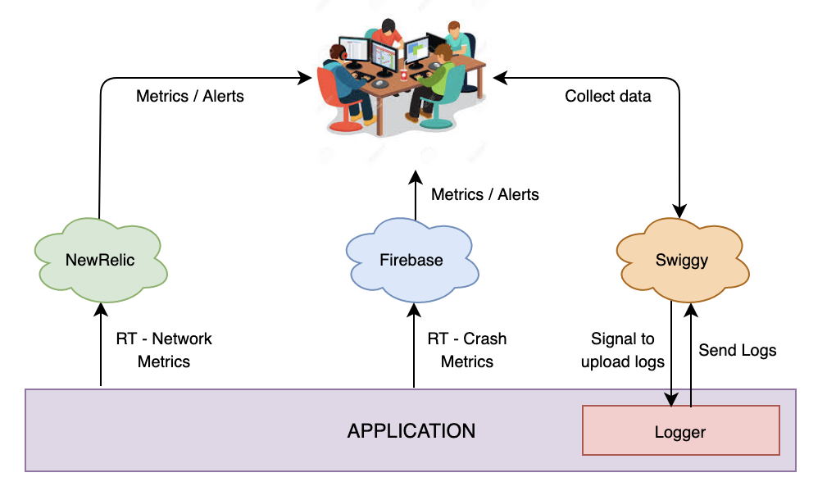

**THEORY EXERCISE:**

**What are the key elements of system design?**

System design is a crucial phase in the software development lifecycle where the overall architecture of a system is created. It defines how the system will achieve its functional and non-functional requirements and how components interact with each other.

Below are the key elements of **system design**:

1. Requirements Analysis

2. System Architecture

3. Component Design

4. Data Design

5. Interface Design

6. Security Design

7. Scalability and Performance Design

8. Reliability and Availability Design

9. Testing and Validation

10.Deployment Design

11.Maintenance and Evolution

**Software Testing**

**LAB EXERCISE:**

**Develop test cases for a simple calculator program.**

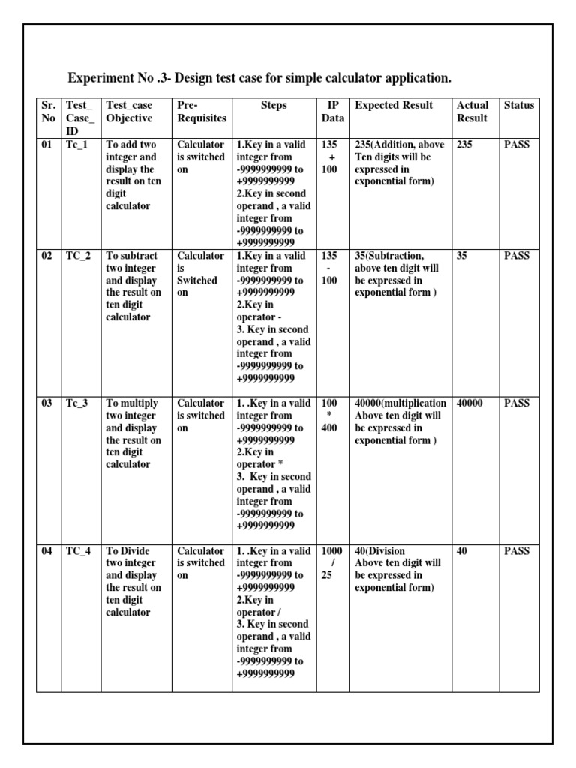

**THEORY EXERCISE:**

**Why is software testing important?**

**Software testing** is important because it ensures the quality, reliability, and performance of a software application. Here's why:

1. **Detects Defects**: Testing helps identify bugs and issues early, reducing the likelihood of problems in the production environment.
2. **Improves Quality**: Ensures the software meets the specified requirements and works as expected under various conditions.
3. **Enhances User Experience**: A well-tested application provides a smooth, error-free experience for end-users.
4. **Prevents Failures**: Testing verifies that the software performs reliably, especially in critical environments, preventing costly system failures.
5. **Saves Costs**: Catching bugs early in the development process is more cost-effective than fixing them after deployment.
6. **Compliance and Security**: Testing ensures the software adheres to regulatory standards and is secure from vulnerabilities.

**Maintenance**

**LAB EXERCISE:**

**Document a real-world case where a software application required critical maintenance.**

### ****Case Study: Critical Maintenance of an Online Banking System****

#### ****Overview****

An **online banking system** used by millions of customers faced a critical maintenance issue when a **payment gateway** malfunctioned, preventing customers from making transactions, such as bill payments and fund transfers, for several hours. This issue caused widespread disruption and required immediate attention to restore normal functionality.

#### ****Problem****

**Transaction Failures**: Customers were unable to complete payments or transfer funds due to a **bug in the payment processing module**.

**Data Inconsistency**: Some transactions appeared successful on the frontend but failed to reflect in the backend, leading to confusion and potential data discrepancies.

**Customer Complaints**: Affected users reported errors during checkout and delayed updates in their bank balances, creating a significant trust issue.

#### ****Cause Analysis****

The bug was traced to a **faulty update** to the **payment gateway integration**, which caused **race conditions** when processing simultaneous transactions. The update introduced a flaw in the **transaction queue** system, causing certain transactions to be processed incorrectly or ignored.

#### ****Steps Taken for Critical Maintenance****

**Immediate System Suspension**: The banking system was temporarily taken offline to prevent further transaction errors. Customers were notified via email and mobile notifications about the downtime.

**Root Cause Resolution**: Developers rolled back the faulty update and patched the race condition issue in the payment gateway integration.

**Data Reconciliation**: A manual audit was conducted to reconcile failed transactions and ensure data consistency across all user accounts.

**System Restart and Testing**: The payment gateway was re-integrated, and the system was thoroughly tested under high traffic conditions to ensure stability.

**Post-Maintenance Monitoring**: Real-time monitoring was enabled to track the system’s performance and detect any issues promptly.

#### ****Outcome****

**Transaction Processing Restored**: Users were able to resume making payments and transfers without further issues.

**Customer Trust Restored**: Timely communication and swift action helped rebuild trust among customers.

**System Stability**: The payment gateway was made more robust with better error handling and redundancy to avoid similar issues in the future.

#### ****Conclusion****

This case highlights the importance of thoroughly testing critical system updates, especially in high-transaction environments like online banking, and the need for quick, effective responses during unexpected failures.

**THEORY EXERCISE:**

**What types of software maintenance are there?**

**Software maintenance** refers to the process of updating, improving, and fixing software after its initial release to ensure that it continues to meet user needs and performs reliably. There are several types of software maintenance, each serving a specific purpose.

These types are:

1.Corrective Maintenance

2.Adaptive Maintenance

3.Perfective Maintenance

4.Preventive Maintenance

5.Emergency Maintenance

**Development**

**THEORY EXERCISE:**

**What are the key differences between web and desktop applications?**

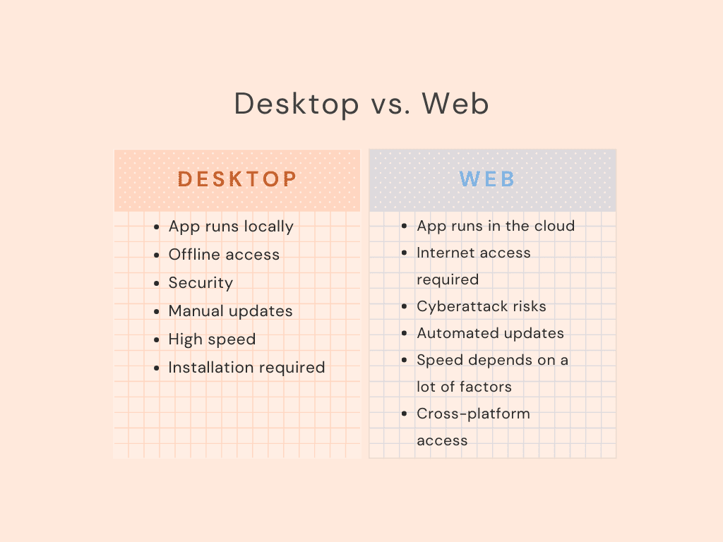

**Web Application**

**THEORY EXERCISE:**

**What are the advantages of using web applications over desktop applications?**

Web applications have several advantages over desktop applications, including: **Accessibility**: Web applications can be accessed from any device with an internet connection and a web browser.

**Centralized data**: Data stored on web applications is centralized, so it can be accessed from any computer.

**Automatic updates**: Web applications receive automatic updates, which ensures they're always up to date and less prone to security breaches.

**Scalability** :Web applications can easily scale to accommodate growing user bases or increased data loads.

**Faster loading times** :Web applications generally load faster initially since they only need to fetch the UI components.

**No installation required:** Users don't need to install the app and, therefore, don't need to maintain it.

**Designing**

**THEORY EXERCISE:**

**What role does UI/UX design play in application development?**

**UI/UX design** plays a critical role in the success of an app by enhancing the user experience and improving the app's usability, retention, and revenue:

**User experience**: UI/UX design creates a positive experience for users, which can lead to increased user engagement and retention.

**Revenue:** Well-designed apps can increase revenue by up to 200%.

**First impressions:** 94% of first impressions are based on design, so a good UI/UX design can help an app stand out and make a lasting impression.

**Competitive** **advantage** :A good UI/UX design can help an app distinguish itself from the competition.

**User feedback:** Usability testing involves getting feedback from real users to identify areas for improvement.

**Iteration:** Iteration is the process of fine-tuning the design based on feedback to make it more user-friendly.

**UI stands for User Interface**, which is the visual appearance of an app. UX stands for User Experience, which is the overall experience of using the app.

**Mobile Application**

**THEORY EXERCISE:**

**What are the differences between native and hybrid mobile apps?**

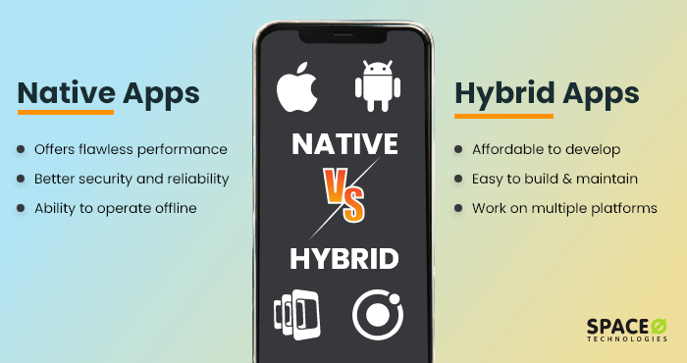

**DFD (Data Flow Diagram)**

**LAB EXERCISE:**

**Create a DFD for a hospital management system.**

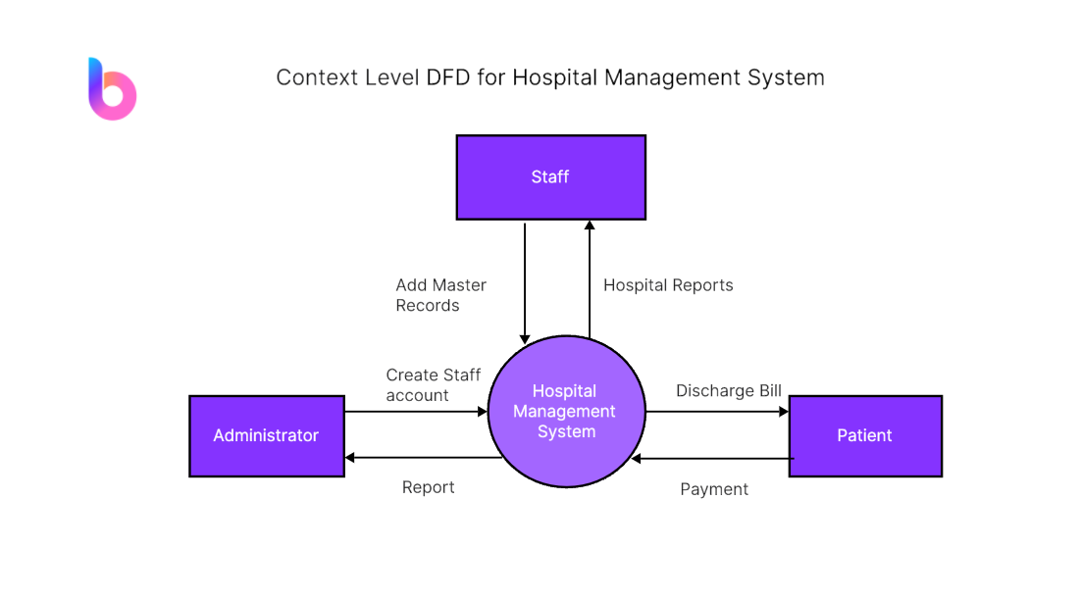

**THEORY EXERCISE:**

**What is the significance of DFDs in system analysis?**

In ****system analysis**, **Data Flow Diagrams (DFDs)**** are significant because they:

**Clarify System Structure**: They visually represent how data flows between processes, data stores, and external entities, helping to understand the system's components and interactions.

**Simplify Communication**: DFDs are easy to understand, providing a common language for stakeholders, developers, and clients to discuss system requirements and design.

**Identify System Gaps**: They help uncover missing processes, data flows, or inefficiencies, aiding in system refinement and troubleshooting.

**Document System Design**: DFDs serve as a standardized documentation tool that supports future maintenance and system updates.

**Define Functional Requirements**: They help clarify the functional flow of data, guiding the development of system features and ensuring they meet business needs.

**Desktop Application**

**LAB EXERCISE:**

**Build a simple desktop calculator application using a GUI library.**

import tkinter as tk

# Function to update the expression in the entry box

def button_click(value):

current = entry.get()

entry.delete(0, tk.END)

entry.insert(0, current + value)

# Function to evaluate the expression

def evaluate():

try:

result = str(eval(entry.get())) # Using eval to calculate the expression

entry.delete(0, tk.END)

entry.insert(0, result)

except Exception as e:

entry.delete(0, tk.END)

entry.insert(0, "Error")

# Function to clear the entry box

def clear():

entry.delete(0, tk.END)

# Create the main window

window = tk.Tk()

window.title("Calculator")

# Entry widget for showing the expression

entry = tk.Entry(window, width=16, font=('Arial', 24), borderwidth=2, relief='solid', justify='right')

entry.grid(row=0, column=0, columnspan=4)

# Button layout

buttons = [ ('7', 1, 0), ('8', 1, 1), ('9', 1, 2), ('/', 1, 3), ('4', 2, 0), ('5', 2, 1), ('6', 2, 2), ('*', 2, 3), ('1', 3, 0), ('2', 3, 1), ('3', 3, 2), ('-', 3, 3), ('0', 4, 0), ('.', 4, 1), ('=', 4, 2), ('+', 4, 3), ]

# Add buttons to the grid

for (text, row, col) in buttons:

if text == "=": button = tk.Button(window, text=text, width=5, height=2, font=('Arial', 20), command=evaluate)

else: button = tk.Button(window, text=text, width=5, height=2, font=('Arial', 20), command=lambda t=text: button_click(t)) button.grid(row=row, column=col)

# Clear button clear_button = tk.Button(window, text='C', width=5, height=2, font=('Arial', 20), command=clear) clear_button.grid(row=5, column=0, columnspan=4)

# Start the Tkinter event loop

window.mainloop(

**THEORY EXERCISE:**

**What are the pros and cons of desktop applications compared to web applications?**

### ****Desktop Applications****

#### ****Pros****:

**Performance**:

* 1. **Faster Execution**: Desktop apps often have better performance since they run natively on the user's device, allowing for faster data processing and smoother operation.
  2. **Better Use of Hardware**: They can access system resources (e.g., CPU, RAM, GPU) directly, making them ideal for resource-intensive tasks such as video editing, gaming, and scientific simulations.

**Offline Availability**:

* 1. **No Internet Needed**: Desktop apps can work offline once installed, which is beneficial when an internet connection is not reliable or available.

**Enhanced User Interface (UI)**:

* 1. **Customizability**: Desktop apps can provide a richer, more responsive, and highly interactive UI, optimized for the operating system (Windows, macOS, Linux).
  2. **Native Look and Feel**: They can offer a better integration with the OS’s native design elements and behavior.

**Stability**:

* 1. **No Browser Dependency**: Desktop apps are not affected by browser updates, compatibility issues, or limitations (e.g., cross-browser issues).

**Security**:

* 1. **Better Security (with proper measures)**: Since desktop apps are local, they can be more secure against certain kinds of attacks (e.g., phishing, cross-site scripting) that web apps are prone to. Sensitive data can be kept entirely offline if needed.

#### ****Cons****:

**Platform Dependency**:

* 1. **Different Versions for Different OS**: Desktop apps must be developed separately for each platform (Windows, macOS, Linux), which increases development and maintenance costs.
  2. **Updates and Compatibility**: Updating desktop apps can be a hassle; users must manually install new versions or rely on an update system. Compatibility with older OS versions might also be problematic.

**Installation**:

* 1. **User Setup Required**: Desktop applications require installation, which can be a barrier for some users who might prefer not to download or install additional software.
  2. **Space Consumption**: Desktop apps can take up considerable disk space, especially for large software suites.

**Maintenance**:

* 1. **Manual Updates**: Users must download and install updates, which can lead to security issues if updates are not applied in time.
  2. **Version Fragmentation**: Since users may not update the app regularly, different users may be using different versions of the application, which can create support and compatibility challenges.

**Limited Accessibility**:

* 1. **Access Restricted to Specific Devices**: Desktop apps are tied to specific machines and cannot be accessed across multiple devices unless configured for syncing or remote access.

**Flow Chart**

**LAB EXERCISE:**

**Draw a flowchart representing the logic of a basic online registration system.**

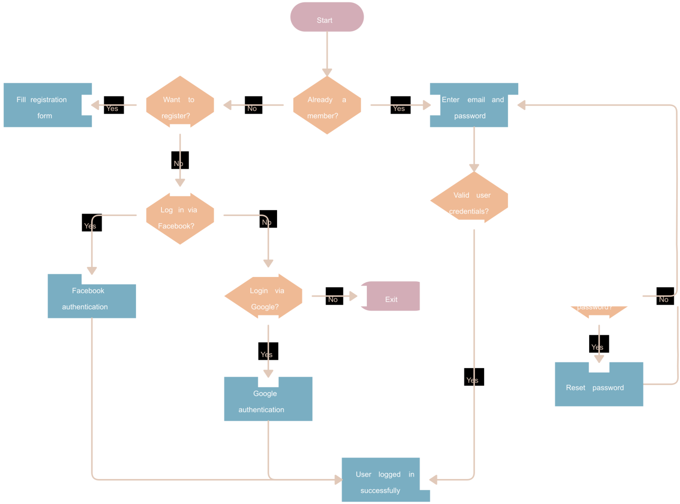

**THEORY EXERCISE:**

**How do flowcharts help in programming and system design?**

**Flowcharts** help in **programming** and **system design** by providing a clear, visual representation of processes, which aids in understanding, planning, and communication. Here's a short overview of their benefits:

**Clarify Logic**: Flowcharts break down complex logic into simple, step-by-step processes, making it easier to understand and implement.

**Improve Problem-Solving**: By visualizing the flow of data or control, they help identify potential issues, inefficiencies, or missing steps early in the design phase.

**Enhance Communication**: Flowcharts serve as a common language between team members, stakeholders, and developers, ensuring everyone understands the system’s workflow.

**Document Processes**: They provide documentation of system or program behavior, which is useful for future maintenance or upgrades.

**Aid Debugging**: Flowcharts make it easier to trace logic during debugging, helping programmers identify where errors occur.